System Design - By Nikhil lohia

- What do you mean by scaling?

Suppose I want to open a book store, and some customers start to come in, now as more and more customers start to come in, so my book store start to get smaller, so to accommodate more customers I will try to either expand my shop or I will shut down this store and maybe I open a big store, now I've a big store and now I see more and more customers come in, so I am increasing my store capacity.


But if more and more customers started to come in, so maybe we can increase my store once again, and my book store is even bigger now. But there is a problem in this approach, what if more and more customers are coming, we can't keep on expanding the book store (management and resources problems are there). So, we are scaling the book store vertically i.e. increasing the size of book store, so by this way we're running out of space. So, the solution big company follows is:
They do not open a store at only 1 place, so I will open different stores at different places, and each of the stores they are made on the basis of your consumption, I do not want to open a huge store, so in this way I am trying to expand my business horizontally, I can use my same store format and open it in a lot of different places. In this way, I can distribute all my customers at different places.
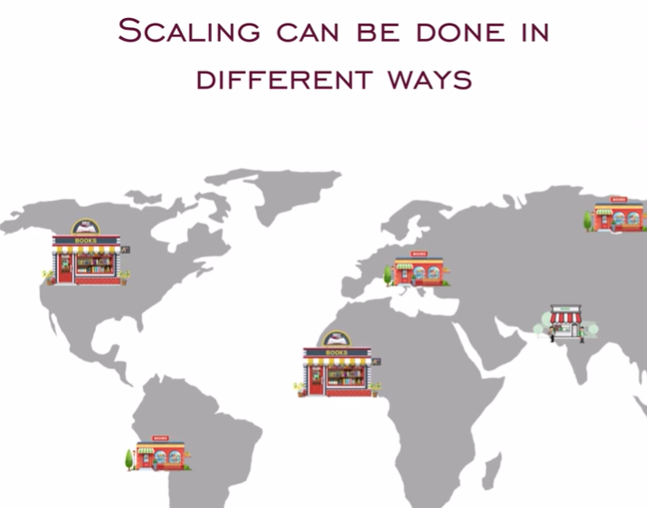

If my store is open only in one region, then we're only targeting customers from this particular region, but if I opened store at all of these different places, so a customer can go to any of the store that is nearest to them, so this is horizontal scaling
You cannot expect to have vertical scaling infinitely but with horizontal scaling you have a lot more scope

Creating a basic application -
Let's say you are developing an application, this application has a db, it will have some disk usage and it will have some CPU as well. Now I want to make this application available to someone, so I run my own server and deploys this application, now people will start coming in and use my application, so the more and more people will try to use my app, so I need more disk, more cpu and more db as well. So, we can increase the disk size and we can use a faster CPU like I have 2 TB of RAM and then I can upgrade to 4 TB of RAM, but if I've to deal with a millions of user, so in that case we can't increase our disk, db and CPU quantity, as it is limited.
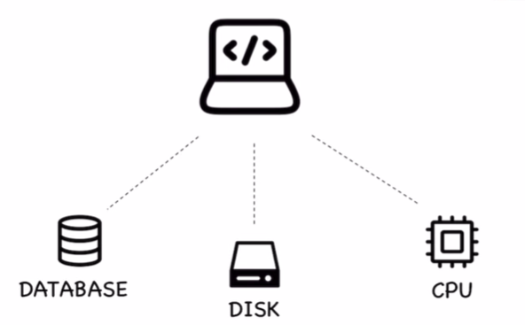
Also when we are dealing with such large memories, then the cost of things also starts to grow.
Eg. We're taking 2 RAMs of 4 TB each, so they'll cost me less then a single piece of 8 TB RAM, so we can't keep on increasing my RAM continuously, b/s the cost keep on increasing and I'll never make a profit. Increasing the memory will keep on increasing the cost. So at that point, app stops scaling, as we can't accommodate more and more customers (like we can't keep on increasing the book store size).
So that's why we cannot just keep on having vertical scaling, so that is where horizontal scaling comes in. Now we take up our app and we will try to deploy it in two different regions of the world. So now all of my customers that were coming from all the way to the world only in one region, this was causing a problem. We have now deployed our applications in 2 diff regions, and now some customers can reach over one region while the other users can reach over other region. So we partitioned our users and we're able to give same service.

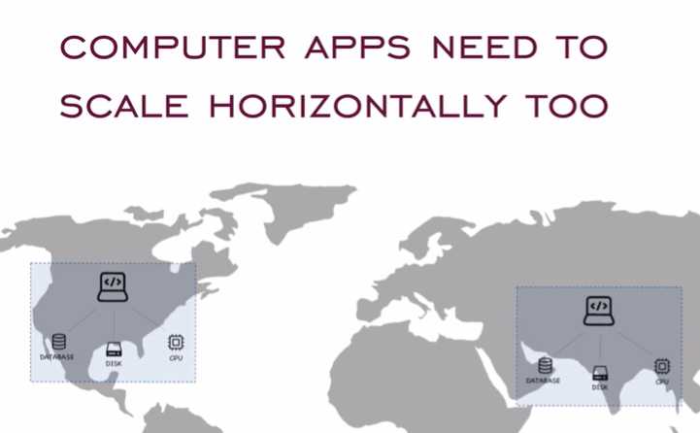
So, we cannot just keep on scaling up our application vertically, you need to have diff servers all throughout the world, that's why we've so many services in all diff regions of the world that's why there is a concept of latency b/s it depends which server are you trying to connect to.

Client-Server Architecture
We interact with a single or multiple users via client server architecture.
A client is someone who requests some piece of information and server sits on the other end and gives that piece of information back, so this is how everyone is interacting with each other.
Let’s say we have a book store, and a person decides to come to a book store, that person is a client. Now, there should be someone present over there to the book store that can answer person’s queries, they can tell you where the book is located, where you can find it and how do you pay for it.
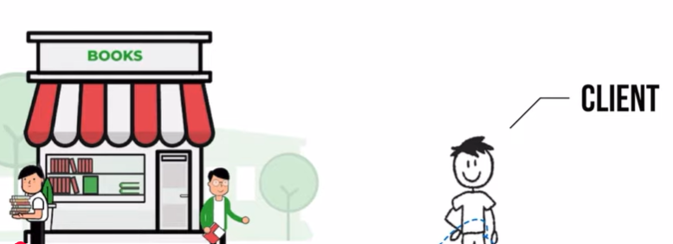
So, this book store will have some kind of cashier/clerk that can help the person with all the information.
This cashier is the server. This is how we make the interactions.

CLIENT-SERVER Model
I have an app running that has a db, some disk and some CPU, and it is located somewhere centrally, we are building this app somewhere and wherever we deploy this app, so this entire thing is called a server, or we can say it to be a cloud.
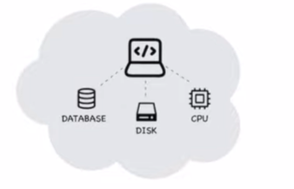
This app is uploaded somewhere and I want to interact with it. So, my clients can be anyone, I can have a person who is accessing my application from a laptop, or I can have a person who is accessing my app from a mobile, and similarly we can have all different clients as well
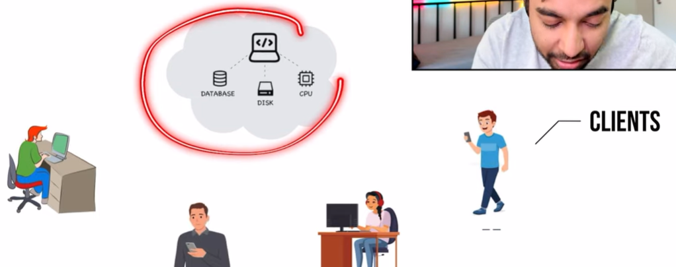
So, this is how we are communicating, so I have a server and these are all different type of clients. This is a client-server communication. We can say, me or my web browser is a client and this app is being hosted on a server which is giving back all the responses.
Another example of client server architecture other than application is: Gaming server
Eg. We can have a game that is available on a lot of different platforms, so this game is hosted somewhere on the cloud and we can have different devices that are connecting to the same server for information. All these devices are client.
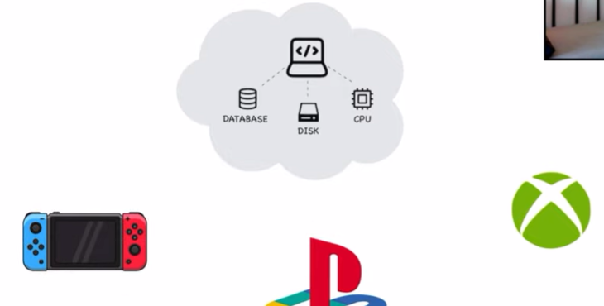

Another example is mailbox account, if we purchase a maibox account then we have all these different clients that can access my email, so we have an email server, and from this email server I have all of these apps that are fetching my information for me.
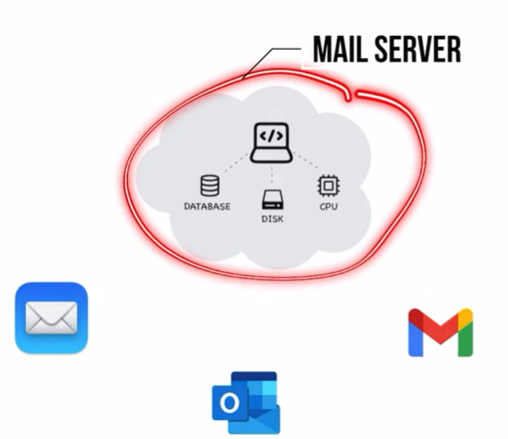
Server can handle all different type of clients and all these apps are based upon the usage and scenario in which we are building our app, for gaming server only gaming clients can connect to it, for email server only email clients can connect to it
But if we have web browser, then all these diff type of devices they have web browser too, so they become my client
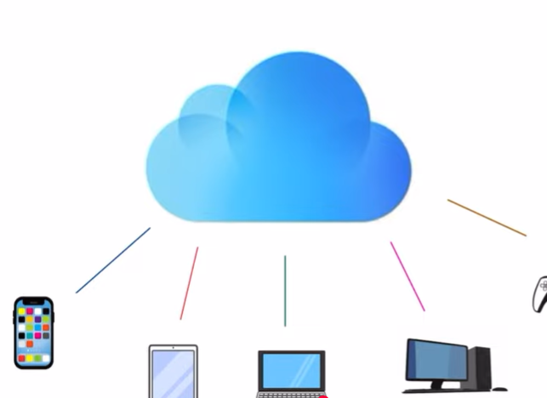
Eg of book store: We can have all different type of clients and the store clerk is serving all of them
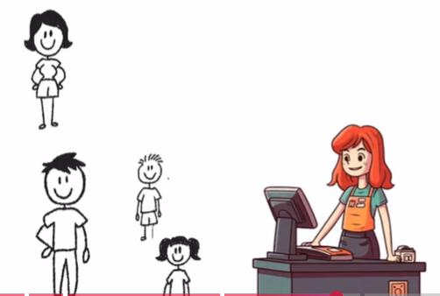
Advantages of client-server connection:
- Central Resource Management
Eg. In the book store we’ve a sales person, this person is a kind of central resource, they’ve all the information about all the books that are available, all the sales that have been made, how many customers came in, how many bought a book, what are the profits, this person knows everything.
To know anything about book store, so we will go to this person and they can tell you everything.
Similarly, when it comes to system design, we’re having server in that. This is where our app is deployed and all the clients are connected, this server has all the information. We know what type of people are coming to our application, from what geographies are people connecting, what is the total hit count, what is the total visitor count, I’ve all of these information and we can store all of these informations in our db.
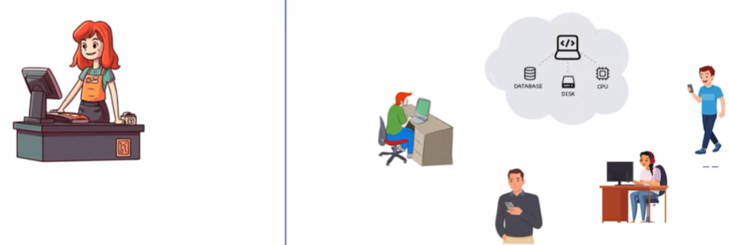
So, by this client server architecture we’re able to manage everything centrally, if I want to block the user I can do this and they will not be able to access our app.
Eg. If we just make a small change, it can be reflected to every client that is connected, so it makes managing things very easy

- Scalability
Eg. In my book store, I have a clerk and all of these customers (i.e. clients). Now, everything is going good and this salesperson is able to handle all the customers coming in, suddenly a lot more customers starts to come in so it could be possible that this salesperson is not able to handle all the traffic (i.e. customers) that means some of the customers will return.
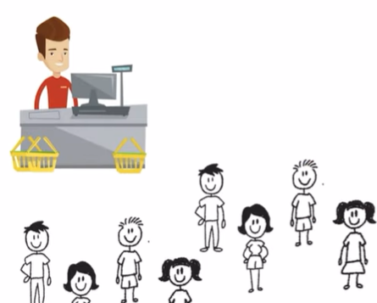
One option we can have is we can hire a new person who is more qualified and more effective and who is more efficient. So, we just scale up and this person can handle all of the traffic.

Similarly, when it comes to system design, for my initial app I was only serving a couple of customers, suddenly my app got popular and I’ve a whole bunch of new customers coming
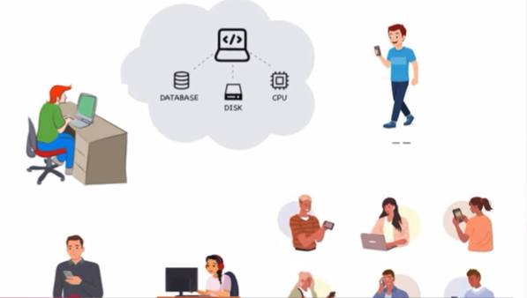
Everyone is trying to load up my app, and then my app will slow down which made customers unhappy. So, I will start scaling up by increasing my CPU, or I can use even more faster discs or scale up my db sizes, in this we can scale up the server which handles all new traffic

- Flexibility of reach
It means we can just deploy our app at one place in the world and since it is internet everyone is able to access app.
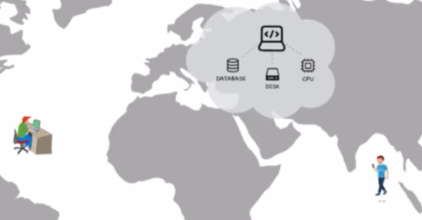

Disdvantages of client-server connection:
Let’s say I have same cashier available at my book store and for some reason this person feels sick and is not available to come to job that day, so all of the customers are unhappy because the store is closed and there is no one to serve them. So, I only had single point of failiure if this person is not available then there is no one available to serve
So, in case of failure we can hire an additional part time worker and they can serve
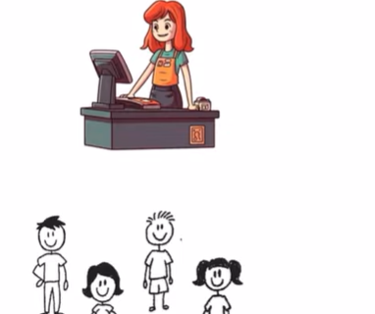
And for the computer apps, l have my app running on one server and currently everyone is connected, but what if service goes down what happens if my disc gets corrupted or we’ve any bad entries in our data, so our app will go down and nobody will be able to connect. So, again it is single point of failiure
So, we can have a backup db and a backup disc and then we can restore our app

- Network Congestion
Eg. In a book store I only have one sales person and he is handling the current traffic we’ve suddenly more customers coming in so every customer they’ll have to wait a little more to be served and this cause slowness in our service.
Similarly in our app if there are no or some users connected and our service is very fast bur as more and more people start to connect to our app, so the app response time can slow down a lot and we start to experience some congestion and our app speed goes down.
So, in case of book store I can hire 2 person at the same time, then some of the people will go to the first person and some of the people will go to the second person, in this way stores handle the traffic
In case of app, instead of deploying app only at one place in the world we can deploy our app at 2 places in the world so some bunch of people will be connected to server 1 and the other bunch of people will be connected to server 2 and both these servers can be managed by a central db system.
- Security Risks
In a book store, if this particular person is compromised, it means thief can steal all of the resources this person had, they can have access to all of the information about the book store and all the money
So, in that case we can have security guards outside the book store to take care of thief

Similarly for a computer app your app get compromised just by hacking the server so hacker can directly attack the server, if I do not have security protocols in place and then this hacker they can exploit my server.
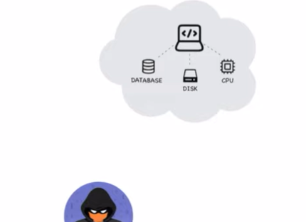
So, in that case we can have some protocols like we can enable encryption, we can enable two factor authentication, we can enable pass keys.
Suppose we do online shopping and we’ve added all the items to the cart but at the checkout page the website becomes so slow that our transaction doesn’t succeed, in that scenario we’ll close that website and we’ll try to go on to a different website to shop the same product.
In system design this problem is called as load balancing
Load balancing is a very fundamental concept, we’re creating a model where we’ve all clients and servers, now I want all of the clients to be happy only then my app will be successful only then we have lot of views on our website, so all the clients should be balanced and they get the service that they need.
In a client-server model, load balancing is one of the challenge
Let’s say my book store is very big, it has music library, digital books, physical books and it also has a cafe, so I'll be expecting a lot of traffic. I had a server available and all of my clients were coming to get them serviced. A lot of customers coming in and because of so many customers a single server can get overwhelmed. It could be possible that the server is unable to process all of these customers in time, eventually it is possible that some of the customers will be unhappy and they’ll just leave the store.
So, either we can change the server, we can have an efficient person who is doing it or instead of having a single lane you can have multiple lanes like in a supermarket we’ve multiple counters, so in that case some of the customers go to a separate lane and some of the customers go to a separate lane, this way we can reduce the stress of each of the server
Now what happens when a new customer comes in, let’s say I’m done with shopping and I want to go to the billing counter, so I will choose the shortest line, there is a very less chance that I’ll choose longest line
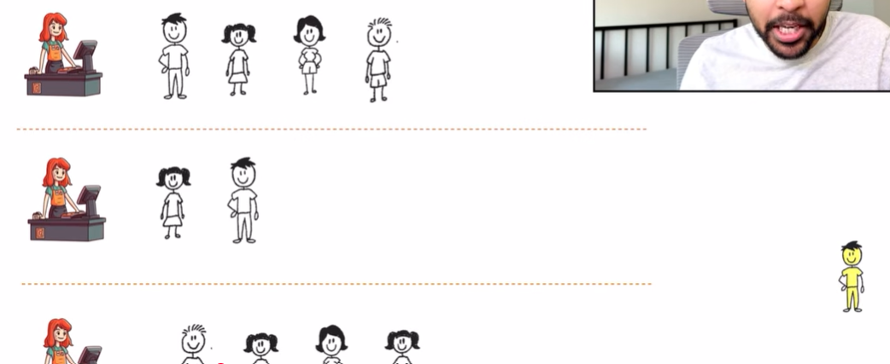
So, we’re trying to balance the load at each of the server, so this is called Load Balancing
Now, in a computer app, our server has cpu, db and disk.
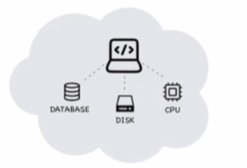
Server looks like this:
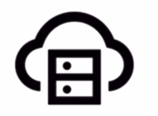
I have my server and it is serving all the clients, let’s say there is some event going on like a sale then suddenly I’ll have a lot more clients who wants to connect to the same server, this server will now get overwhelmed and response time will get slow down so some of the customers might get unhappy and they just leave the website.
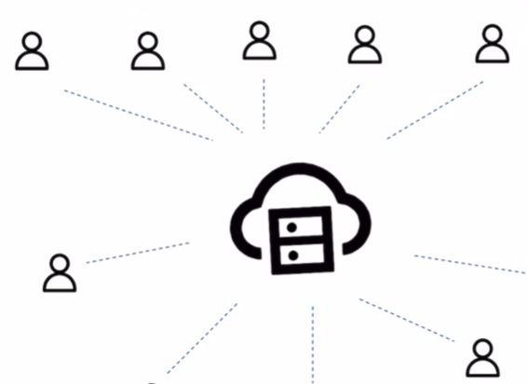
So, instead of having my app deployed only on one server we can deploy our app to multiple servers, now these multiple servers are like multiple lanes and clients could just connect to any of them, this way we’re able to reduce the load on each of the server and all of our clients are happy.
Now, the problem arises when a new client comes in, in case of supermarket we’re able to see that this line is the shortest and we could just join that line but when we’re on the internet we cannot see the servers and we cannot see the client, also we don’t know how many servers are available, so how do we decide which server to connect to
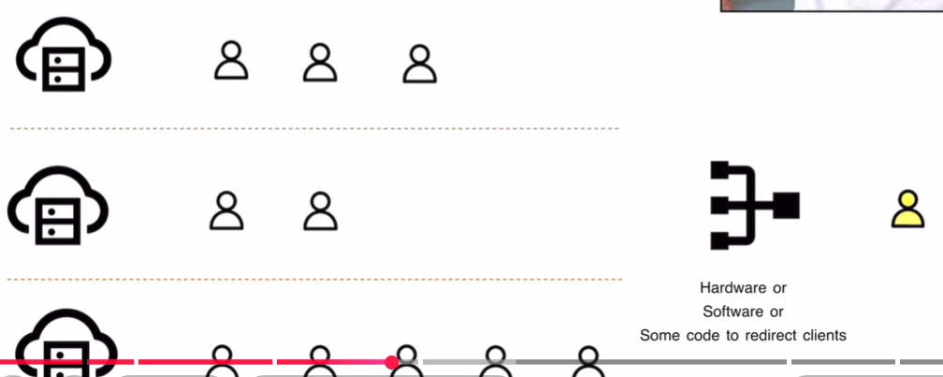
This is where concept of load balancer comes in. This load balancer could be a hardware or a software or it could simply be a piece of code that decides that if a client comes where should they go should they go to the 1st server, should they go to the 2nd server or 3rd server and there are multiple ways by which we can allot this client to any of these servers, our end goal is that each of these servers should be balanced.
So, when the new client comes in, we can make the connection by starting off with the server that has the least no. of requests, so load balancer knows about all the information about each of the server and how many clients are connected, so when I’ve a client connected, so this load balancer takes the client and allot it to a server that has least no. of requests
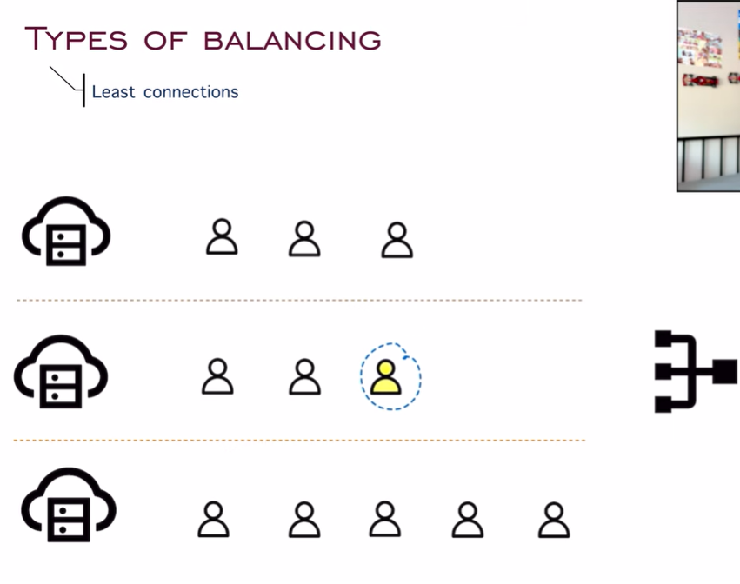
And if another client comes in, this client can go to any of the server which has least no. of requests, support this client goes to the first server, now it could be possible that server no.1 was able to finish all of these 3 clients and they no longer exists.
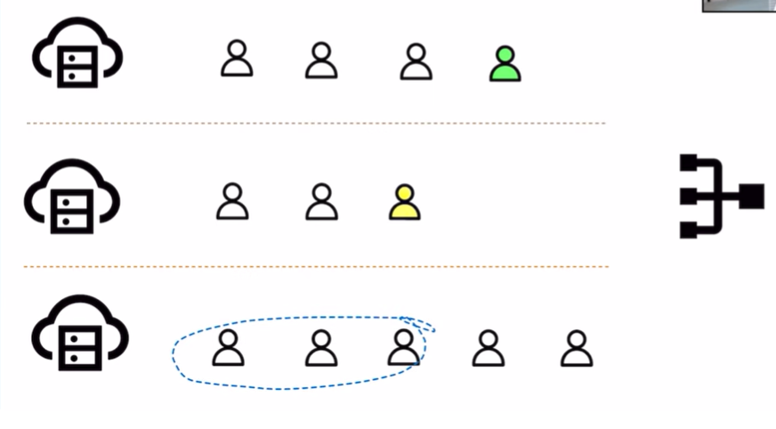
Since there are new clients coming in, load balancer will check I have a new server where I can allot the load and these new clients goes to server no.1

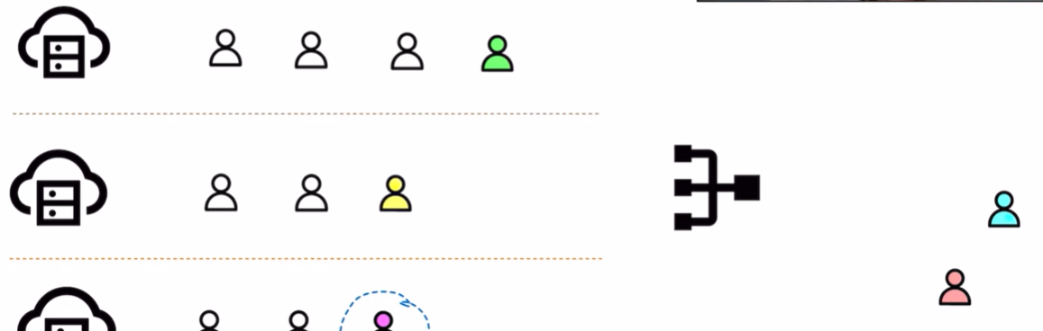
Similarly this process will go on and we could keep on allotting clients. This load balancer is making sure that all of the servers have balanced loads and this kind of scenario is usually efficient when each of my server is configured in exact same way.
Other way we can do load balancing is round robin scheduling.
Let’s say I’ve lot of candies available and I want to distribute it to a lot of kids, so I keep giving one candy to each student at a time I’ll keep repeating this process until I’m out of candies. This ensures that all of the kids have equal no. of candies. Similarly, I’ve all the servers available and these are my clients, so by round robin scheduling I can keep on allotting all of these clients one by one. So this is trying to keep load balanced b/w each of the servers.
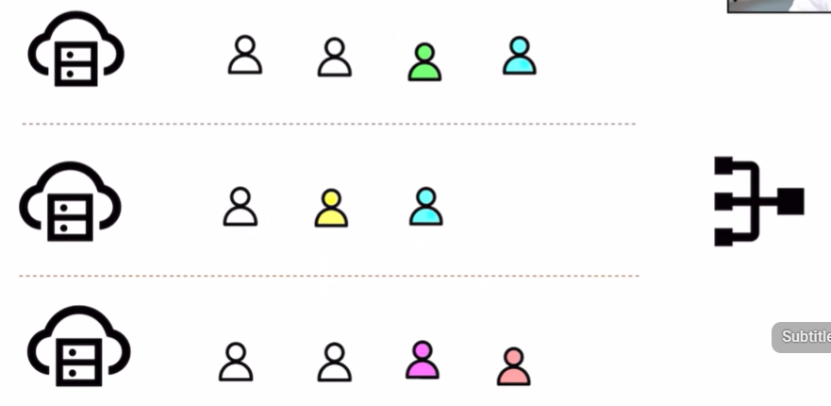
There can be a problem with this approach, let’s say these 2 users they had very tiny requests, they want to download an image and they are done. According to round robin scheduling, next client goes to server 1 and next client goes to server 2
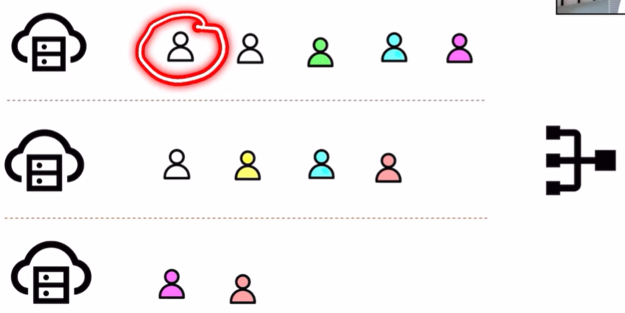

Now, it is possible that this possible user is blocking the server, as he is downloading a huge movie, and all of the other clients are waiting so sometimes round robin scheduling is not desirable, so we can also do weighted round robin scheduling.
In weighted round robin scheduling we allot all of the clients based on server’s capacity.
So, this particular server is more efficient than rest of the server.
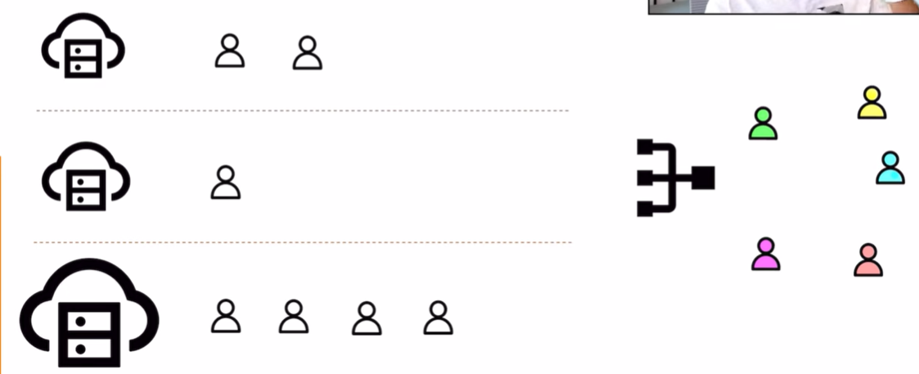
This server is huge and can process more requests, so instead of allotting clients one by one , we can allot the efficient server 2 clients and all other servers one client at a time, so we are relying on servers capacity and based upon that we’re doing all of our load balancing, b/s this third particular server is able to serve the customers quickly, so we are doing weighted scheduling to maintain balance b/w all of these servers.
One more method is IP Hashing, it means that there could be some particular clients that are always connected to only one particular server. Let us say, I’ve a server in North America, and all of the users in yellow they’re in North America region, so they’ll get best service when they are connected to server in North America. So, when I’m scheduling all of my clients, I’ll schedule one client to server one, other client to server 3 but whenever I see yellow client, I’ll allot them to server2, so once again I am making sure that all of my load is balanced
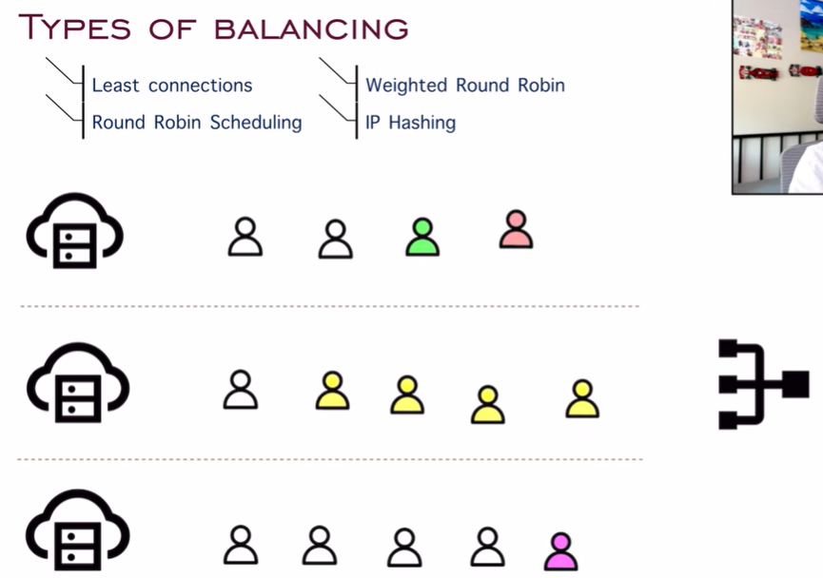
Suppose if I go to super market, where it says 10 items or less, so we are fixing certain type of clients to certain type of server, so only clients with 10 items or less can go to this particular counter. This is how IP hashing works.
And there is a concept of free version and premium version, if I take premium subscription I will be served faster, so in this they apply concept of load balancing , so for premium users they have a dedicated server, so if there is any other user they’ll get randomly assigned to any of the other servers that are available but for premium users they’ll have a dedicated line and they’ll only be allotted to premium servers.
Advantages of load balancer:
We have a system where everyone was connected to the same server to a system where we’ve multiple servers and all of my traffic is distributed , the advantage is that all of my traffic is working in parallel and everyone is happy, as my load got distributed.
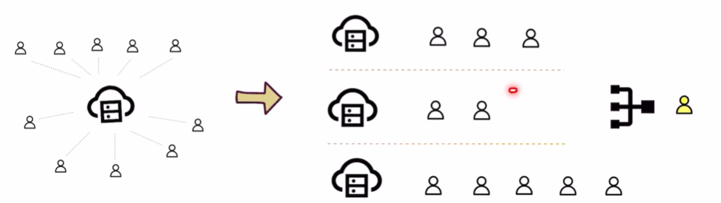
But this is not the only advantage, let’s say I’ve my system set up like this, now suddenly a lot of customers starts to come in, so this particular model allows us to scale up my system as well, if I’ve so many users coming in, so we can deploy our app to one more server as well, so now I scaled up my system and we can start allotting all of the users to balance my load effectively.
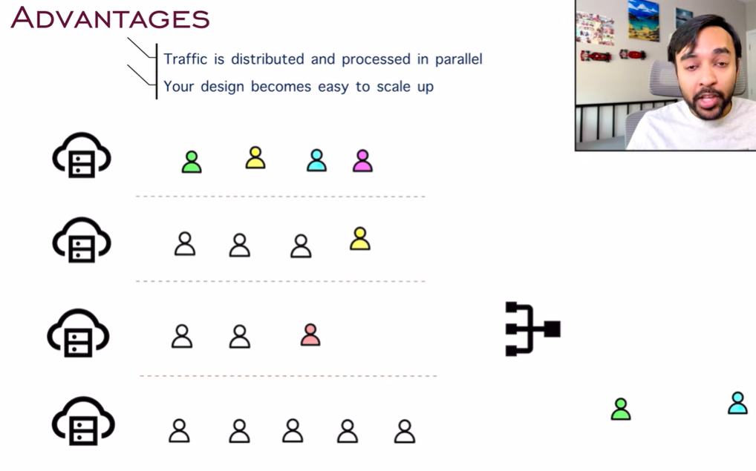
Having a load balancer allows us to have high availability as well, it means that let’s say one of my server goes down, but I still want service to be accessible, so load balancer takes all the clients that are connected to faulty server and it will allot them to these different servers, so service time might go down but my service did not end, my clients can still connect and they’ll be served.
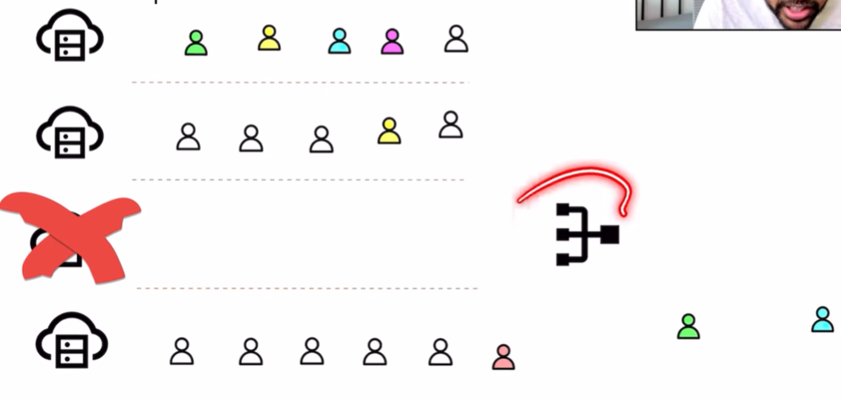
Disadvantages of load balancing:
- This system is not easy to design, load balancer can get very complex and we have to handle all these scenarios as well what if server goes down, what if there is a lot of traffic, what if client is taking so much time, or client is unresponsive, so load balancer has to manage all of it and writing code for it is not easy.
Managing all of the servers in parallel is also very complex
- Load balancer becomes single point of failure, if the load balancer goes down then these clients cannot connect to the servers, so load balancer becomes single bottleneck and entire system could crash
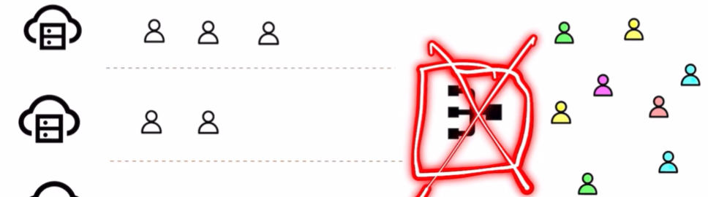

- Security- We have to make sure that all my security protocols are in place when we’re implementing a load balancer b/s if load balancer gets compromised then we can divert all of the traffic to just one server, and then that particular server gets overwhelmed and goes down, and along with that all server goes down, so entire system once again crashed
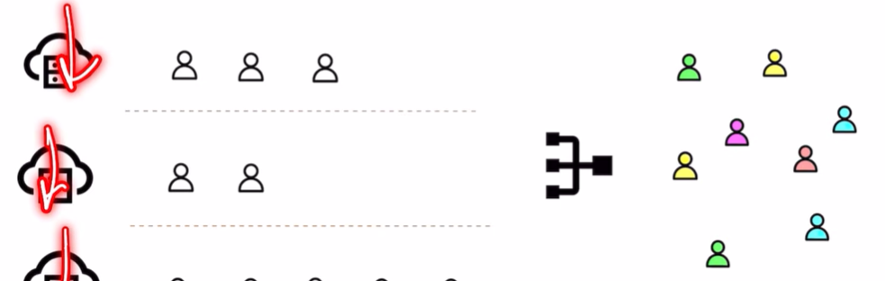

Caching:
Our end goal is to serve a lot of customers and we’ve to do that in fastest possible way, we can increase the speed of serving customers if we somehow already know what the customer is coming in for.
Eg. I have a book store and even before the customer comes in I already know that maybe the customer wants this item, I can have that ready, this is exactly what we’ve to do with computer application.
Eg. I have a large book store and some customers are coming in, in all of the book stores one thing is common which is a huge collection of books, but in every book store there is a counter or a shelf where we have some of the popular books already available, and when customer walks in b/s of these books are popular there is a very high chance that the customer came in looking for these books, and this speeds of the process so much. If the shelf wouldn’t have been there then the customer have to look at all of these other books, so it may possible that the customer just leave or they don’t even find the book just because of shortage of time.
So we keep one section of the book store as best sellers and this best seller is caching, so it saves time of client, increases efficiency of server, and it increases speed of transaction as well.


Now, for computer applications we use caching everywhere
Caching symbol is:

Caching is a kind of memory or a small db, which has a very high speed.
You have a hard drive and you also have a RAM, RAM is a type of cache memory, that is why we say if you increase your RAM then the speed will go up that is b/s we are loading all of the content that we need frequently and if RAM size is huge then we’re able to load a lot of content.
But this RAM is expensive than the main memory that is why we can replace hard disk with RAM and RAM cannot also be so huge that we’re just dumping all of the data on it, so if we increase RAM size so performance will improve up to a certain limit.
Like In a book store, if we increase the size of best sellers, then it defeats the entire purpose, so our cache memory is relatively very less when compared to the main memory, and it has to be very fast.
So, we have a server and whenever users were querying any data, so we went to our database and asked I want this, the db returns some information and then give it back to the clients.
This server could be a news website and all of the clients are requesting for specific articles, let’s say there is a breaking news, so client1 is asking for article1, client2 is asking for article2, and other clients also they are asking for article1, for each of the requests this server is going to make 5 requests to the db, and then get all the articles again and again.
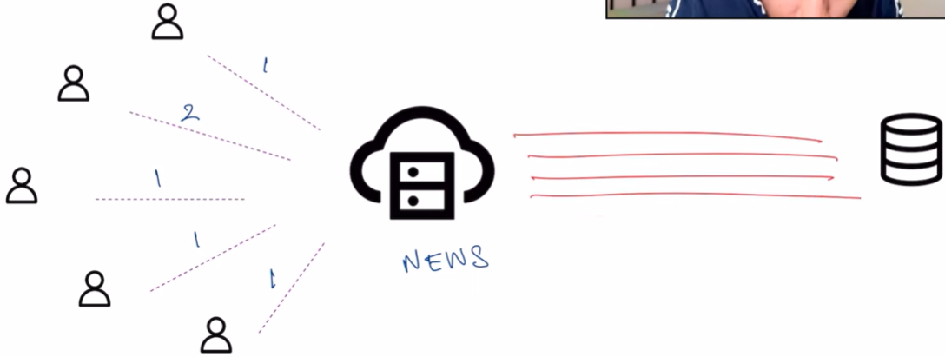
This is where we introduced caching, and now this server will try to first look into cache, in the cache if it finds article1 then it does not need to go and look into the db, it can simple return article from the cache, and the 1st user will be very happy. Then user two is requesting for article2, the server will again look into the cache, it cannot find article in here so now it will go into our db and then get the result and will go to user2, then for other users the server will query the cache and serve all these 3 clients very fast.
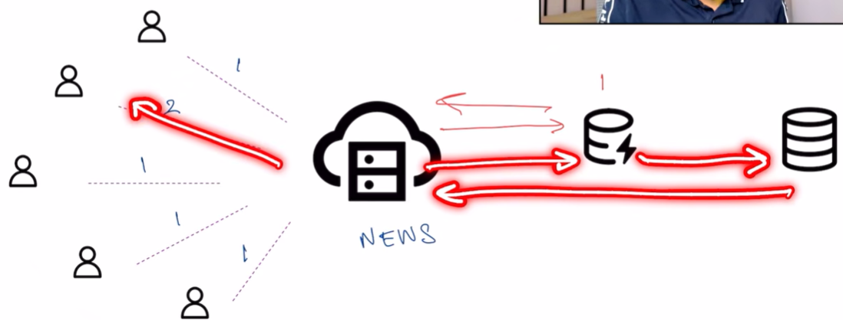
We’re reducing how many times we have to look up in this main memory and this is saving a lot of time.
Important caching terms:
Let’s say our system is set up like this, and we’ve a new server available, and in my cache I’ve all these articles available, and I’ve a main db that has all the articles, also I’ve bunch of users that are requesting some of the articles, user1 is asking for article1, I will look into my cache and then return it to server.
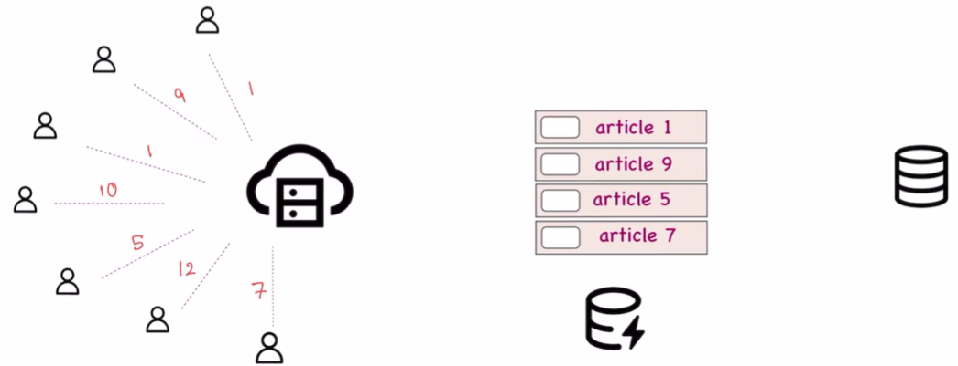
If we’re able to find anything in our cache, this is called as cache hit.
Now 2nd user is asking for article9, we are able to find it in our cache so we simply return it, this is also cache hit.
3rd user asks for article1, it is available so once again it is cache hit
Next user is asking for article10, but when we look into cache we cannot find article10 in it, so we will try to look into our main memory/db, this concept is known as cache miss, b/s we looked in to cache but didn’t find it
Then Article5 is cache hit, article12 is cache miss and article7 is cache hit
A system is supposed to be good if it has a good cache hit to cache miss ratio
Higher the value of Cache Hit/ Cache Miss, better is the system
That is we’re able to look up a lot of my requests in the cache
But how we’re determining what articles we want to keep in the cache?
It could be possible that we’ve to change this, suppose if suddenly there is some breaking news, and all the viewers want to know about the breaking news, so all of them they tried to look into the cache they won’t find it, and then they tried to find in the db, so our cache miss count is increasing so our ratio is decreasing. So we need to add a new element into the cache, but cache has very small memory and it is very limited, that means we’ve to remove any one element from the cache, let’s say we’ve removed article5, so article5 will be gone and new element (breaking news) will be inserted in my cache, but how do we decide which article do I’ve to remove
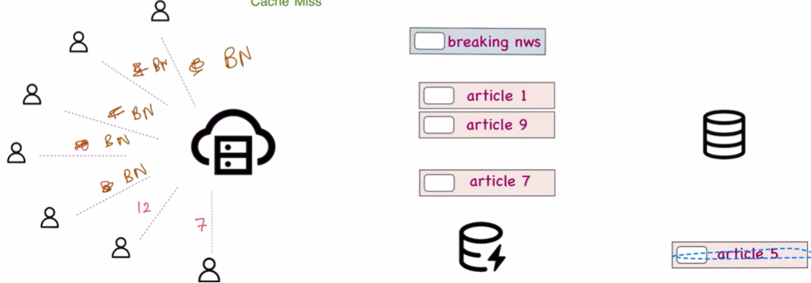

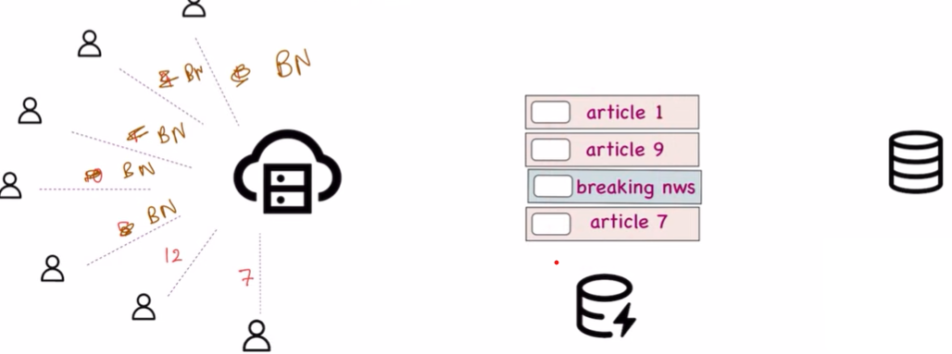
We’ve to remove the article in such a way that cache hit : cache miss ratio will remain good, only then our system will be fast
There are multiple strategies by which we can determine which element do we have to actually evict from the cache.
Cache Eviction Methods:
Let’s say we’ve all these articles in our cache, and this new article (breaking news) is coming in, so we’ve to remove any one of these articles, so first strategy is random eviction, so randomly I’ll choose article16 so we remove it, and put this new element into the cache
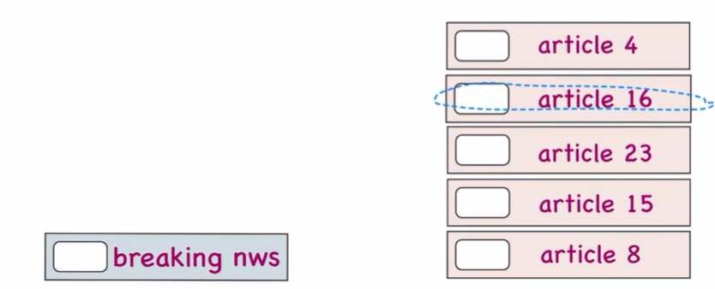
It will work sometimes, suppose there is a website which has lot of random articles and one of the article has low viewership in that scenarios random eviction is very helpful
Next technique is FIFO: First in First Out
We have article4 then 16 then 23 then 15 and then 8 so these got added in my cache one after the other, so when next member comes in:
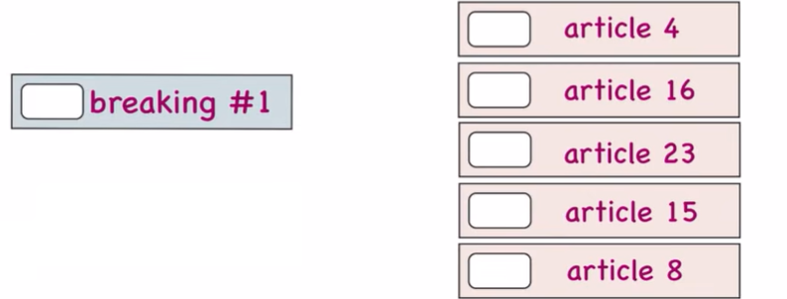
So, we remove article4 that was added in the first place and breaking #1 comes in, now if we add another member to our cache:
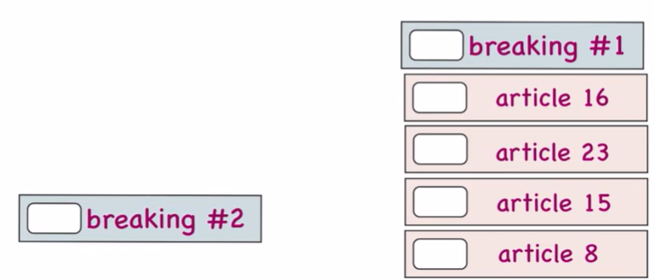
So, article16 goes away and new member will get added to the cache
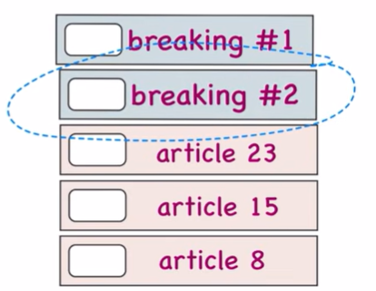
So we keep on adding elements one by one and keep on removing the old ones, but it could be possible that the article is old but it is still very popular so in that case we use LFU (Least Frequently used) technique
In LFU, we will try to evict the element from the cache that has the least hit count, let’s say we have all of these elements in my cache and I’m also storing how many times I’ve actually done cache hit on these elements, so we’re keeping a count of how many time I’ve hit this article, so if it was FIFO method then article4 will gone away, but article4 has 53 hit counts, but article16 only accessed 15 times, so if we’ve remove an element from the cache, so we should get rid of article16 element and we will take new element and that will be added to our cache
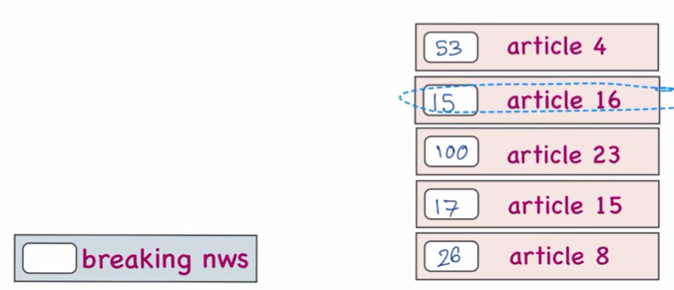

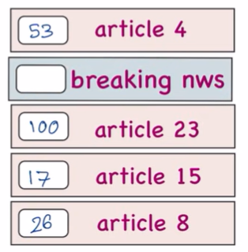
Similarly, there is another method which keeps a track of LRU (least recently used) so this is keeping a track of when was the cache item accessed for the last time, so we’ve all these elements in our cache and along with all these elements I’m also storing when there was cache hit on these elements
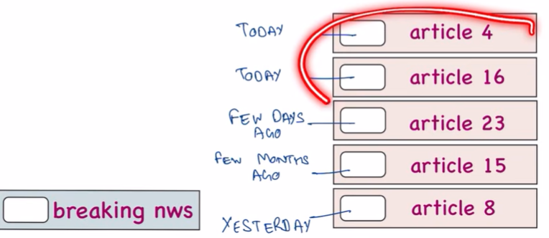
Article4 and 16, accessed today, article8 was accessed yesterday, article23 was accessed a few days ago and article15 was accessed a few months ago, and when new article comes in we’ve to evict one element, so the term which is least recently used is article15, other than that all of the articles are recently used, so we will evict article15 based on this algorithm
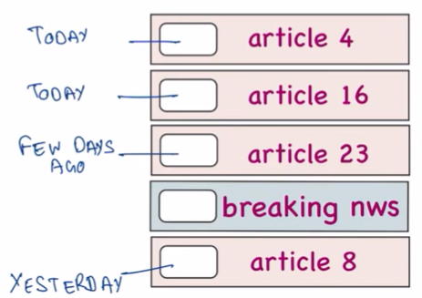
We can think like article15 was really popular some days ago and now the trend went away and we’ve new viral trends coming up, like Instagram only wants to keep the latest trends, so we’ve to get rid of the trend that was in past.
We decide the eviction technique based on something that we’re implementing according to our usecase, and there is no best method
Eg. Book store, which book do you remove from the shelf, do we remove the book which is from the past, or do we just remove book randomly, or do we remove the book that we placed first, or do we remove the book based on frequency of people buying

Things to be careful about:
Let’s say my system is currently using something like this:
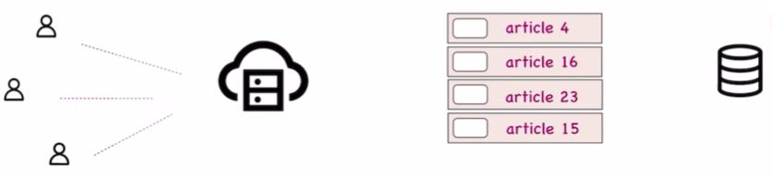
All of these users are requesting and my cache has some articles, let’s say both of our users want article16, and this is present in our cache and we’ll return them the article, but what happens if someone updates article16 on db, then this article is no longer consistent with the cache it could be possible that article16 is of older version and on db we might have newer version, we can see on webpages as well that until we keep on refreshing every time we won’t get the new content loading, so we’ve to keep track that if an article gets updated in our db so we’ve update cache also, so we’ve to implement our system such that our cache remains updated all the time
Another issue is coherence, let’s say our server is deployed at multiple places in the world then each of the server have a different cache so we’ve to decide should all of our caches be exactly same or should all of our caches be according to the users who are accessing them and this becomes a challenge when we are actually implementing all this in our app code.
Last is Security, just like all of these articles sometimes we might have to cache our login creds also
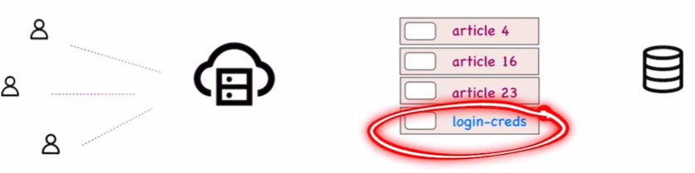
Eg. We would check on stay signed in and then whenever we open our account it just opens without asking for a login that is b/s caching is involved in this, so we’ve to be mindful of how much time we have to keep these login creds in our cache, we can’t just have them over there permanently that way there can be some malicious activity on our account, we have to remove these creds as determined by our policy

